SCALARS AND VECTORS
Vector quantities have both magnitude and direction, whereas scalar quantities have magnitude only.
SCALARS | VECTORS
Temperature, potential difference, distance, time, speed, power, mass, length, energy (work), pressure, volume, charge, density | Displacement, velocity, force (weight), acceleration, momentum, electric field strength, torque, angular momentum, moments

Addition of Vectors
The resultant of two or more vectors is the single vector which produces the same effect (in both magnitude and direction).
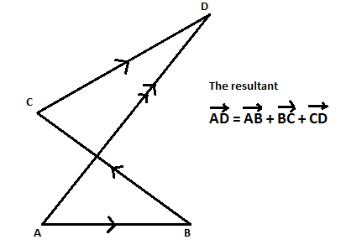
Parallelogram Rule
If two vectors,andare represented in magnitude and direction by the side OA and OB of a parallelogram OACB, then represents their resultant.
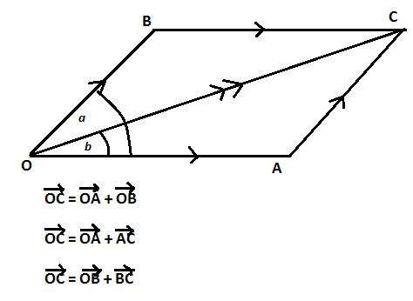
Question
Find the resultant of two forces, 8N and 6N acting at an angle of 38⁰ to each other using both scale drawing and calculation.
Components of Vectors
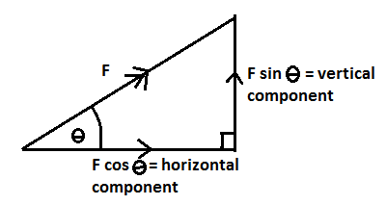
Question
Using components, find the resultant of two forces of magnitude 6N and 8N acting at 38⁰ to each other.
Lami’s Theorem
If three forces A, B and C are in equilibrium, then
A/sin a = B/sin b = C/sin c (similar to the sin Rule). See also Triangle of Forces and Polygon of Forces in Text.
