Bottom of Form

The Remainder Theorem and the Factor Theorem
This section of the CAPE MATHEMATICS UNIT 1 syllabus discusses the historical method of solving higher degree polynomial equations.
As we defined in class a polynomial function is of the form:
f(x) = a₀x^{n} + a₁x^{n-1} + a₂x^{n-2} + ... + a_{n}
where
a₀ ≠ 0 and
n is a positive integer, called the degree of the polynomial.

Example 1
f(x) = 7x⁵ + 4x³ − 2x² − 8x + 1 is a polynomial function of degree 5.

Dividing Polynomials
First, let's consider what happens when we divide numbers.
Say we try to divide `13` by `5`. We will get the answer `2` and have a remainder of `3`. We could write this as:
`13/5 = 2 + 3/5`
Another way of thinking about this example is:
`13 = (2 × 5) + 3`
Division of polynomials is something like our number example.
If we divide a polynomial by (x − r), we obtain a result of the form:
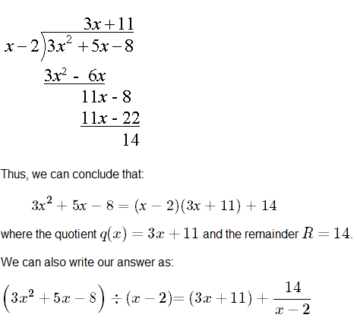
f(x) = (x − r) q(x) + R
where q(x) is the quotient and R is the remainder.

Example 2
Divide f(x) = 3x² + 5x − 8 by (x − 2).

The Remainder Theorem
Consider f(x) = (x − r)q(x) + R
Note that if we let x = r, the expression becomes
f(r) = (r − r) q(r) + R
Simplifying gives:
f(r) = R
This leads us to the Remainder Theorem which states:
If a polynomial f(x) is divided by (x − r) and a remainder R is obtained, then f(r) = R.

Example 3
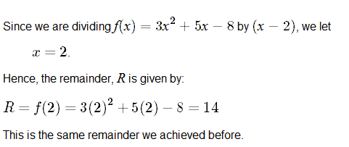
Use the remainder theorem to find the remainder for Example 1 above, which was divide f(x) = 3x² + 5x − 8 by (x − 2).

Example 4
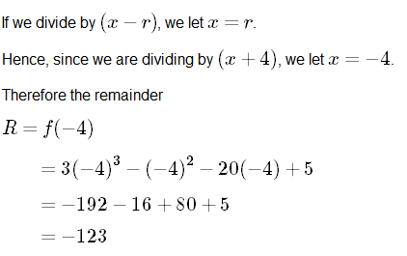
By using the remainder theorem, determine the remainder when
3x³ − x² − 20x + 5
is divided by (x + 4).

The Factor Theorem
The Factor Theorem states:
If the remainder f(r) = R = 0, then (x − r) is a factor of f(x).
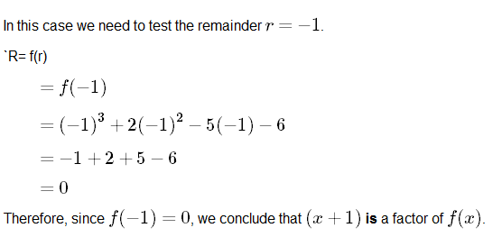
The Factor Theorem is powerful because it can be used to find roots of polynomial equations.

Example 5
Is (x + 1) a factor of f(x) = x³ + 2x² − 5x − 6?

Exercises
1. Find the remainder R by long division and by the Remainder Theorem.
(2x⁴ - 10x² + 30x - 60) ÷ (x + 4) Ans: 172
2. Find the remainder using the Remainder Theorem
(x⁴ − 5x³ + x² − 2x + 6) ÷ (x + 4) Ans: 606
3. Use the Factor Theorem to decide if (x − 2) is a factor of
f(x) = x⁵ − 2x⁴ + 3x³ − 6x² − 4x + 8. Ans: YES
4. Determine whether `-3/2` is a zero (root) of the function:
f(x) = 2x³ + 3x² − 8x − 12. Ans: YES

