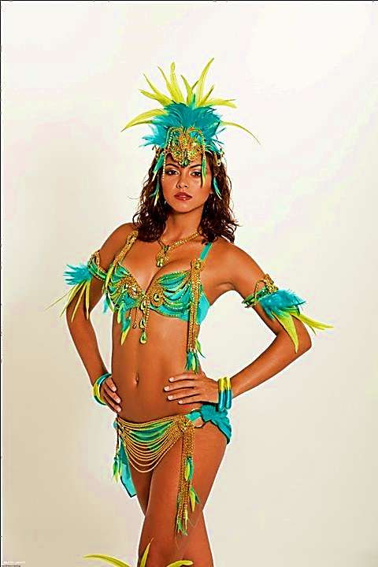C:\Users\vikash\AppData\Local\Microsoft\Windows\Temporary Internet Files\Content.IE5\BONT5MT8\MC900078766[1].wmfC:\Users\vikash\AppData\Local\Microsoft\Windows\Temporary Internet Files\Content.IE5\1WCQUOHT\MC900391024[1].wmf

***Sponsors***

Follow us on TWITTER

Like us on FACEBOOK

For more information and direction contact us at:

*Email*: [partyvybez@hotmail.com](mailto:partyvybez@hotmail.com)

*Phone:* 363-4465

**ADMISSION**: from 10:30

|  |  |
| --- | --- |
| MEN | $200 |
| WOMEN | $150 |

**Music by***: Eternal Vybes/Dorenzo/ Genisis*

**Special guest appearance by:**

**MACHEL MONTANO!!!**

CARNIVAL 2K13

***BAND LAUNCHING***

**MONEYVYBEZ**

All inclusive

**SATURDAY**

**January 19th**